Week Six: Confidence Interval (CI) about μ

# Week Six Goals

* The Student’s T-Distribution
* What is a Confidence Interval about μ?
* Interpreting a Confidence Interval
* Meeting the Assumptions/Requirements of T-Curve
* Building a Confidence Interval about μ –WITH StatHelper
* Building a Confidence Interval about μ –WITH MINITAB 19
* CI Example with Summarized Data
* Answering follow-up questions about the CI
* Working with an Existing CI
* Understanding how a CI Changes
* Important Z-values Associated with Confidence Intervals
* Estimating Sample Size with Numerical Data
* Additional Week Six Example

# Student's T-Distribution (aka, The T-Curve)

The following explanation is adapted from [Stat Trek](https://stattrek.com/probability-distributions/t-distribution.aspx).

The t distribution (aka, Student’s t-distribution or T-curve) is a probability distribution that is used to estimate the population mean (mu, μ) when the sample size is small and/or when the population standard deviation is unknown. It is unrealistic to think that we would ever know the population standard deviation ***so we will always use the t-distribution when estimating μ.***

We we will always use the t-distribution (T-curve) for building confidence intervals (CI) about μ.

## Degrees of Freedom (df)

There is not just one T-curve; there are an infinite number of T-curves. All t-curves are bell-shaped and symmetric; the exact shape, however, is determined by its degrees of freedom. The degrees of freedom (df) refers to the number of independent observations in a set of data. When estimating a mean score from a single sample, the number of independent observations is equal to the sample size minus one (df = n – 1).

* When working with samples of size 8 (n = 8), the t-curve will have 7 degrees of freedom.
* Similarly, a t-curve having 15 degrees of freedom would be used with a sample of size 16.

***You do not need to understand degrees of freedom; you just need to use them (df = n-1). The information in this box is a further discussion of degrees of freedom, if you are interested. You may skip over this box.***

For those that are interested, [this website provides](https://blog.minitab.com/blog/statistics-and-quality-data-analysis/what-are-degrees-of-freedom-in-statistics) a nice discussion. Here is an excerpt:

**The Freedom to Vary**

First, forget about statistics. Imagine you’re a fun-loving person who loves to wear hats. You couldn't care less what a degree of freedom is. You believe that variety is the spice of life.

Unfortunately, you have constraints. You have only 7 hats. Yet you want to wear a different hat every day of the week.



On the first day, you can wear any of the 7 hats. On the second day, you can choose from the 6 remaining hats, on day 3 you can choose from 5 hats, and so on.

When day 6 rolls around, you still have a choice between 2 hats that you haven’t worn yet that week. But after you choose your hat for day 6, you have no choice for the hat that you wear on Day 7. You *must* wear the one remaining hat. You had 7-1 = 6 days of “hat” freedom—in which the hat you wore could vary!

That’s kind of the idea behind degrees of freedom in statistics. Degrees of freedom are often broadly defined as the number of "observations" (pieces of information) in the data that are free to vary when estimating statistical parameters.

Another way to say this is that the number of degrees of freedom equals the number of "observations" minus the number of required relations among the observations (e.g., the number of parameter estimates. In this unit, one degree of freedom is spent estimating the mean and the remaining *n*- 1 degrees of freedom estimate variability.

## Properties of the t-Distribution (aka, the t-curve)

The t distribution has the following properties:

* The mean of the t-curve is equal to 0.
* The shape of the t-curve is symmetric and bell-shaped but depends on df = n - 1.
* With infinite degrees of freedom, the t distribution is the same as the Z-curve (standard normal curve).

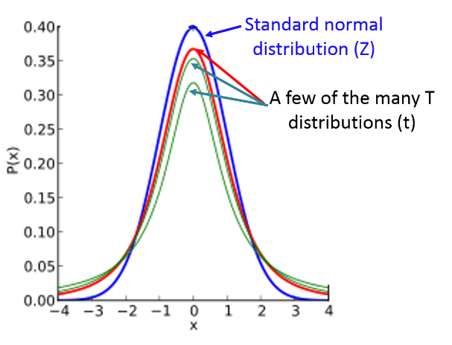

## What is a T-Value?

Recall: A Z-score is a measure of location on the Z-curve. Positive z-scores are to the right of the mean and negative z-scores are to the left of the mean.

A t-value is a measure of location on the specific t-curve for the degrees of freedom needed for the sample. There is a different t-curve for each degree of freedom. All t-curves are bell-shaped and symmetric. They are all centered around the sample mean. What changes is how SPREAD OUT the curve is. For small degrees of freedom, the peak is not as high in the center and there is more of the curve out in the tails. For higher degrees of freedom, the peak in the center gets higher and there is less area in the tails.

In this image, the green curve has the highest degrees of freedom. The blue curve has the smaller degrees of freedom. The higher the degrees of freedom, the closer the t-curve gets to becoming the standard normal (Z) curve (the red curve). Look at the area in the right tail. The T-curve has a greater area in the right tail than the z-curve.

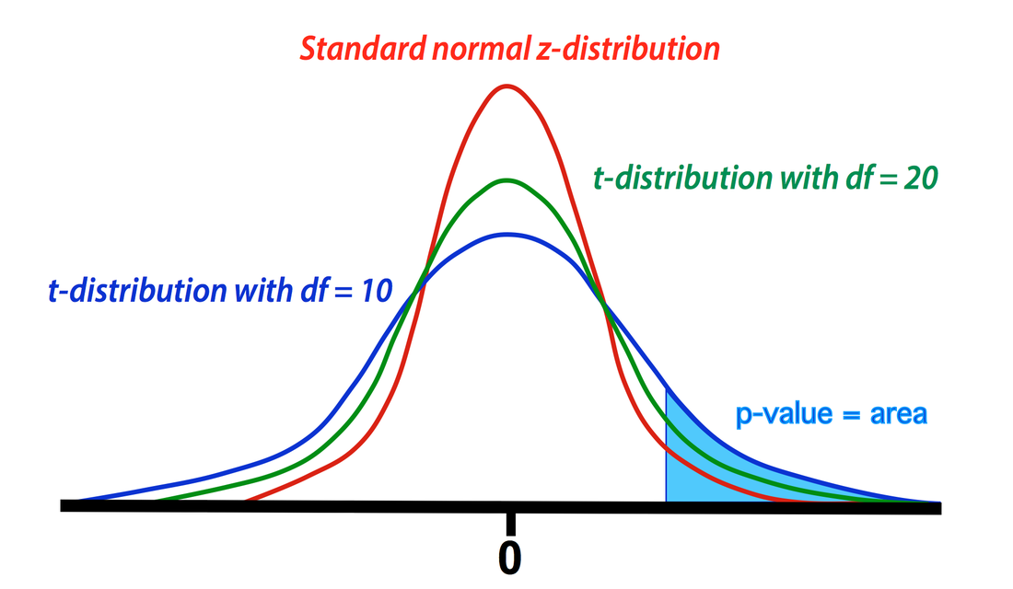

## Student’s T-Table

There are many different t-tables. StatHelper and Minitab are programmed with the t-table. Web based T-calculators can also be used to find a t-value. Here is an example of one such [t-calculator website](https://goodcalculators.com/student-t-value-calculator/).

**Below is a T-table built so that T-values are found if you know the area in the RIGHT tail.**

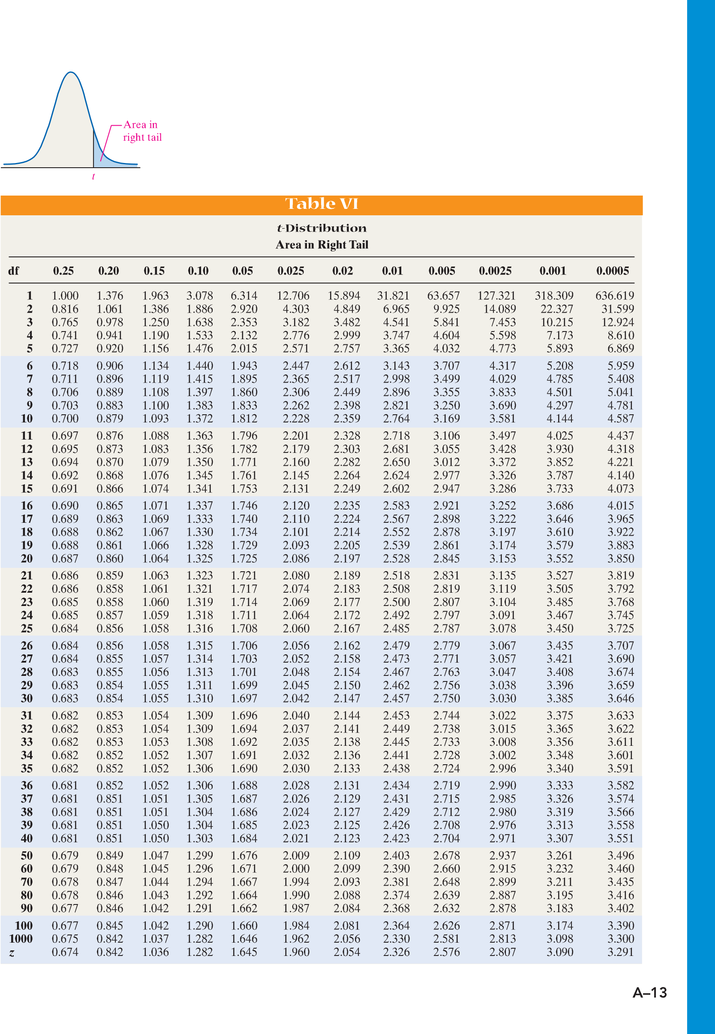

For example: If we were asked to find the t-value for a sample of 30 (n = 30) such that there is .05 probability of being greater than it, we would use df = 29 and the area in the right tail = 0.05. The T-value = 1.699.

**Below is a T-table built so that T-values are found if you know the area in the CENTER of the curve.**

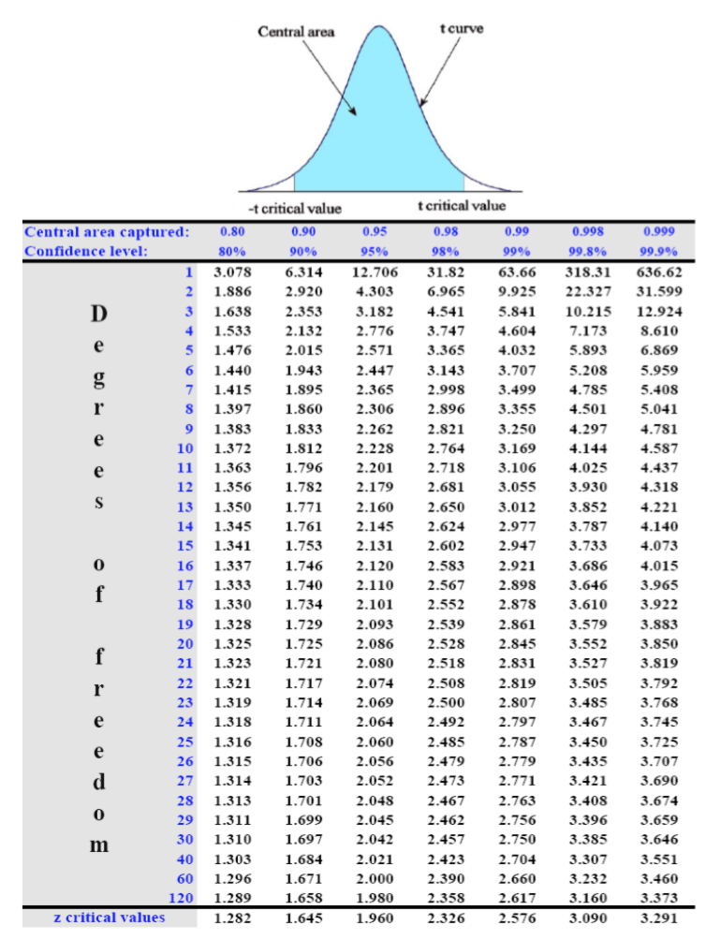

For example: If we were asked to find the t-value for a sample of 30 (n = 30) such that there is .05 probability of being greater than it, we would use df = 29 and since there is a symmetric area in the left tail, the sum of the two tails is .10, leaving .90 in the center area. The T-value = 1.699.

## Accessing a T-table with Technology, if needed

The t-table is programmed into ALL TI calculators and is part of all statistical software. All TI calculators use the table when building a CI about mu; not all TI calculators allow you to access it. Calculator users, check to see if you can access the t-table: 2nd VARS (Distr) --> **InvT**. To find the t-critical value with this feature, you need the area to the left and the degrees of freedom (calculated df = n-1): InvT (area left, df).

Similarly, StatHelper uses the T-table to build the CI about μ but is not set up for you to access it.

Minitab 19 does allow you to access the T-table: Calc🡪Probability Distribution🡪T

There are T-calculators online that can also be used to find the t-value. Here is an example of one such [t-calculator website](https://goodcalculators.com/student-t-value-calculator/).

If we were building a CI about μ by hand, then we would need to access a T-table. We will be using technology to build the CI about μ and therefore, we have little need to access.

My video example provides a look at building a CI about μ by hand, if you are interested.

# What is a Confidence Interval (CI) about μ?

In our next lesson, we will use information from a random sample to make conclusions about the population. This is called **Inferential Statistics** and it is our final unit of this course. We will learn to estimate a parameter by building confidence intervals and performing hypothesis tests. This week, we will build confidence intervals about p, the true proportion.

## Vocabulary you need to know

Parameter: a numerical characteristic of a **population**

Statistic: A numerical characteristic of a **sample.**

**In this section, we will be using a statistic to make an inference about the parameter.**

A confidence interval will be stated in parentheses and listed: (lower bound, upper bound).

The width of the interval depends on the level of confidence. As the confidence level increases, the lower bound gets lower and the upper bound gets higher.

The most common confidence levels are 90%, 95% and 99%, although you can build a confidence interval with any level of confidence. As you increase the level of confidence, you build a wider interval. A wider interval is not more accurate. It is just more likely to capture the true proportion since you cast a "bigger net". It reminds me of this Garfield cartoon:

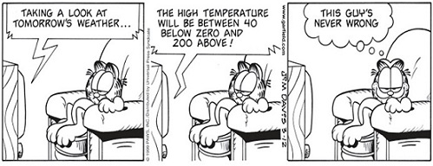

Garfield is right. The meteorologist is never wrong because he is stating a very large range of temperatures. It is like me saying "I am 100% confident that every student will get between a zero and a 100 on my next test!" Duh. Of course, they will.

We need to build confidence intervals that are accurate, not just wide. To do this, you want to make the standard error small and this is accomplished by making n large (increasing the sample size).

A confidence interval is calculated as follows: Point Estimate Margin of Error.

Recall that μ is the symbol for the population mean (true mean) and is the symbol for the sample mean. In this unit, we are interested in estimating the population mean, μ, by using the best estimate we have. Our best estimate for μ is called the point estimate for μ and it is the sample mean To build a confidence interval, we will build an interval around the sample mean by adding and subtracting a ‘margin of error’.

Margin of Error (ME) is the maximum expected difference between the population mean and the sample mean. To calculate the margin of error, we multiply the standard error (SE) by the number of standard errors away we want to go from the center (Tcrit). The Tcrit is a T-value, a location, for the number of standard errors away from the sample mean. Margin of Error is often denoted ME (our e-text uses EBM for Error Bound for Mean instead of ME). . A confidence interval begins with a POINT ESTIMATE (the best estimate for what we are studying) and then adds and subtracts a calculated margin of error.

Point Estimate ± Margin of Error

Sample mean ± (# of SE away)(SE)

Our best estimate for μ is the sample mean. We say that our Point Estimate for μ is

The standard error (SE) is the sample standard deviation divided by the square root of n.

The tcrit depends on level of confidence

and degrees of freedom df = n -1. It is a measure of how many standard errors away we want to go to build this CI.

Also note that the confidence interval's width ***increases*** as the degree of confidence ***increases***. For example, for a given sample a 99% confidence interval is always wider than the 95% confidence interval since it must "cast a wider net" in order to have a better chance of capturing the true value.

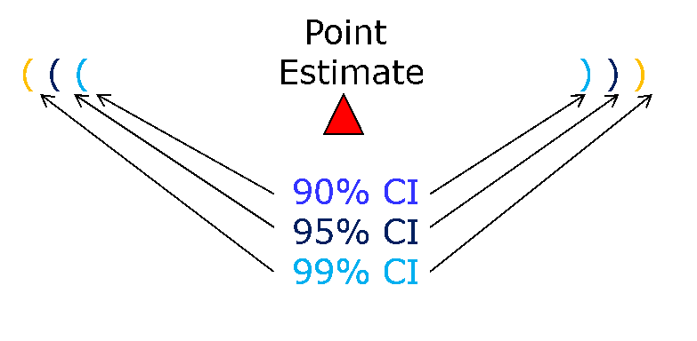

To build a 90% CI, the Tcrit for 90% confidence and df = n-1 is used.

To build a 95% CI, the Tcrit for 95% confidence and df = n-1 is used.

To build a 99% CI, the Tcrit for 99% confidence and df = n-1 is used.

A 95% confidence interval means that if we were to take 100 different samples and compute a 95% confidence interval for each sample, then approximately 95 of the 100 confidence intervals will contain the true mean value (**μ**). In practice, however, we select one random sample and generate one confidence interval, which may or may not contain the true mean. The observed interval may over- or underestimate **μ**. Consequently, the 95% CI is the likely range of the true, unknown parameter, μ.

The confidence interval does not reflect the variability in the unknown parameter. Rather, it reflects the amount of random error in the sample and provides a range of values that are likely to include the unknown parameter, μ. Another way of thinking about a confidence interval is that it is the range of likely values of the parameter (defined as the point estimate + margin of error) with a specified level of confidence (which is similar to a probability). Excerpt [from this website](http://sphweb.bumc.bu.edu/otlt/MPH-Modules/BS/BS704_Confidence_Intervals/BS704_Confidence_Intervals_print.html).

If we used the same sampling method to select 100 random samples and build 100 different confidence intervals, we would expect the population mean to fall within 95 of the confidence intervals. In other words, a 95% level of confidence indicates that we expect 95% of the intervals built to capture the population mean.

We will use technology to build confidence intervals (CI). In my video introduction below, **I build a CI by hand** to give some background knowledge.

## Video Introducing the T-curve and the CI formula with Example from Prof. Coffey

Here is a video discussing Intro to CI: <https://youtu.be/11VjXYRnlAc>

Here is the same video with interpreting: <https://youtu.be/3P5qvoz7fIQ>

# Interpreting a Confidence Interval (CI)

I suggest using one of the following interpretation templates:

“We are ___% confident that the true (population) mean _____________ is between LB and UB .”

*Describe the variable here*

OR

“We estimate, with ___% confidence, that the true (population) mean ________is between LB and UB .”

*Describe the variable here*

We have confidence that the population mean is in the interval we built. We don’t know for certain. When we build a 95% confidence interval, the we say we are 95% confident that the true mean is in the interval.

Saying population mean is the same as saying true mean. This is also the same as saying the mean of all in the population. You can use any of these phrases to describe the mean of the population: ‘True Mean’, ‘Population Mean’, ‘Mean of ALL…’.

# Meeting the Assumptions/Requirements for a T-Curve

There are two requirements that need to be met before we can trust the results of a CI built using a T-curve: Normality and No Outliers. I will only ask you to check the assumption of normality in this course. The assumption of normality means that either the sampling distribution can be assumed normal or the population data can be assumed normal. Since the T-curve is a normal curve, we **must be able to** assume a normal distribution—we must meet the normality assumption.

If the sample size is large enough (n > 30), we know that the Central Limit Theorem allows us to assume that the sampling distribution can be assumed normal.

If the sample size is not large enough (n < 30) and we have raw data, we can construct a Normal Probability Plot (NPP) and if the P-value is > 0.05, we will assume the data come from a normally distributed population.

If the sample size is at least 30, and considered large enough, it does not matter if the NPP fails. The size of the sample will be enough for us to assume we have met the normality assumption. If the size of the sample is small, and you have raw data, you must know to go on and check the NPP>

**THE NORMALITY ASSUMPTION MUST BE MET IN ORDER TO TRUST THE CI RESULTS FROM THE T-CURVE.**

-----------------------------------------------------------------------------------------------------------------------------------------------

NOTE: We will be using technology to build confidence intervals in this course. If you use StatHelper, the results show the work in building the lower and upper bounds of the confidence interval. Minitab 19 only produces the results. The StatHelper and Minitab 19 keystrokes are on the next pages:

# Building a Confidence Interval about μ –with StatHelper

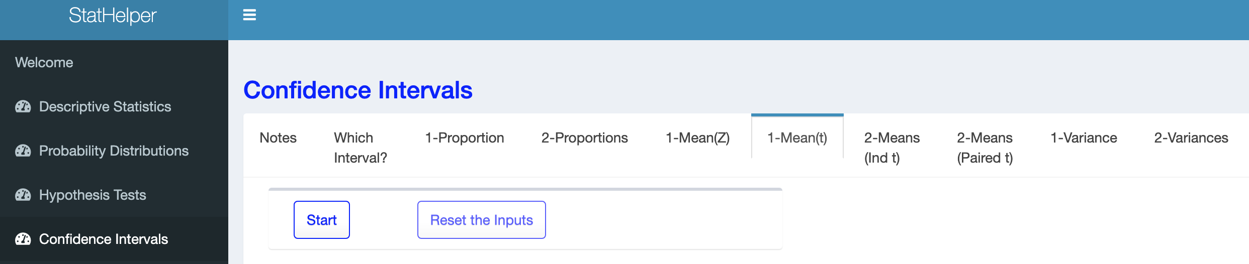

StatHelper Instructions

1. Choose Confidence Intervals from the left side.
2. Choose **1-Mean(t)** from the options across the top.
3. Press Start.
4. **Choose the Form your Data Takes:** If you have RAW data, then select RAW data and select the file to upload. If you were provided , then choose SUMMARIZED DATA.
5. **Input the Confidence Level:** 90, 95, 99, etc.
6. **Select the Type of Interval**: 2-Sided Interval.
7. Click RUN. Your confidence interval is under both the WORK tab and the INTERPRETATION tab.

## Video Demonstrating Using StatHelper to construct a CI from Prof. Coffey

Here is a video using StatHelper to build CI: <https://youtu.be/gda-t7XGuIc>

Example: The U.S. Marine Corps is reviewing its orders for uniforms because it has a surplus for tall recruits and a shortage for short recruits. In the review, heights (inches) were measured for a random sample of male recruits between the ages of 18 and 24. See the table below. The data are saved in the file: 6_Week 6 STAT 145 Data.xlsx under the sheet: **Male Recruit Heights**.

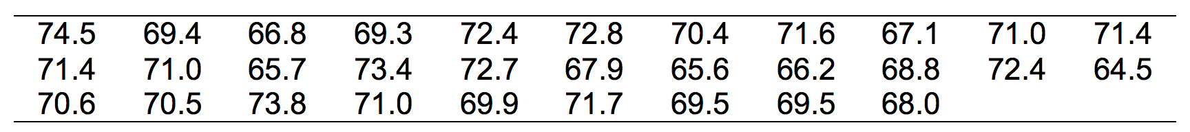

Estimate the mean height for all male recruits between 18 and 24, with 95% confidence. In other words, construct a 95% confidence interval for the mean height of the population of male recruits between 18 and 24.

Think about it:

Before you get started, be sure you can identify the variable and describe the population.

The variable is HEIGHT of male recruits (ages 18 – 24) in Marine Corps; it is NUMERICAL.

The population is ALL Marine Corps male recruits (ages 18 – 24).

**ANSWER:**

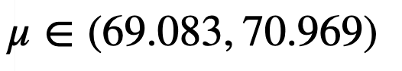**StatHelper Output**

(By the way, this means that the true mean is an element of the set of numbers 69.083 to 70.969)

INTERPRETATION: We are 95% confident that the true mean height of all Marine Corps male recruits (age 18 -24) is between 69.083 inches and 70.969 inches.

ASSUMPTION MET? Since the sample size is bigger than 30, we can assume the normality assumption has been met.

# Building a Confidence Interval about μ –with Minitab 19

If you have raw data in Minitab, then be sure you use the ‘One or more samples, each in a column’ feature.

Click in the white box and select the column of data

Minitab 19 keystrokes

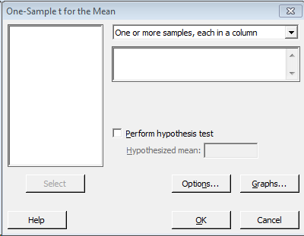Stat🡪Basic Statistics🡪 1 Sample t

Review the choices under OPTIONS. Change the confidence level, if needed.

Be sure the Alternative hypothesis reads **NOT** **EQUAL**

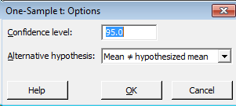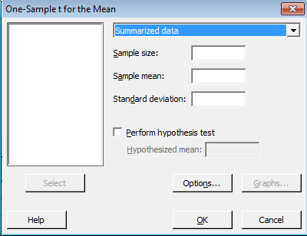

Review the choices under OPTIONS. Change the confidence level, if needed.

Be sure the Alternative hypothesis reads **NOT** **EQUAL**

If you were provided summarized data, then be sure you use the ‘summarized data’ feature.

Enter the following information:

Sample size: n

Sample mean: x-bar

Sample standard deviation: s

## Video Demonstrating Using Minitab 19 to construct a CI from Prof. Coffey

Here is a video using Minitab to build CI: <https://youtu.be/pLh0cSPW1Tw>

Example: The U.S. Marine Corps is reviewing its orders for uniforms because it has a surplus for tall recruits and a shortage for short recruits. In the review, heights (inches) were measured for a random sample of male recruits between the ages of 18 and 24. See the table below. The data are saved in the file: 6_Week 6 STAT 145 Data.xlsx under the sheet: **Male Recruit Heights**.



Estimate the mean height for all male recruits between 18 and 24, with 95% confidence. In other words, construct a 95% confidence interval for the mean height of the population of male recruits between 18 and 24.

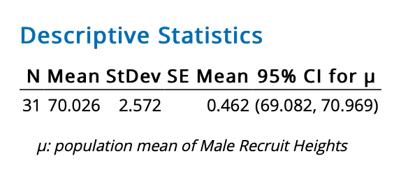**ANSWER: Minitab 19 Output:**

INTERPRETATION: We are 95% confident that the true mean height of all Marine Corps male recruits (age 18 -24) is between 69.083 inches and 70.969 inches.

ASSUMPTION MET? Since the sample size is bigger than 30, we can assume the normality assumption has been met.

# CI Example with Summarized Data

A brand of olive oil is advertised as having 15 percent saturated fats. A nutritionist obtains 13 bottles of this brand of olive oil and tests them for the percentage of saturated fats. The sample mean and standard deviation which she obtained were = 16.1 and s = 2.6. We are told to assume a normal distribution. Estimate the population mean percent saturated fats with 90% confidence.

Think about it:

Before you get started, be sure you can identify the variable and describe the population.

The variable is percent saturated fats for a certain brand of olive oil; it is NUMERICAL.

The population is ALL bottles of this particular brand of olive oil.

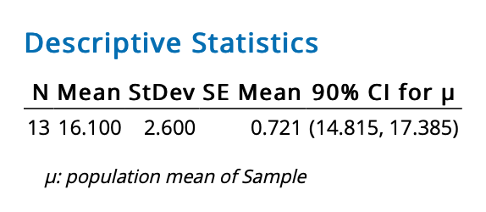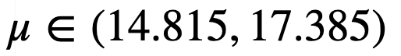**StatHelper Output: Minitab 19 Output:**

### 

INTERPRETATION: We are 90% confident that the true mean percent saturated fats for this brand of olive oil is between 14.815 and 17.385.

ASSUMPTION MET? Since we were told to assume a normal distribution, the normality assumption has been met.

# Answering Follow-Up Questions with the CI

A confidence interval can be used to answer follow questions. Recall that the true mean is a value in the interval, with some confidence. Any value in the interval could be the actual population mean.

It is also important to note, that in order for the confidence interval to support a statement, the entire interval must support the statement.

## Marine Male Recruit Heights Example Follow-up Questions

For example: Our earlier work showed that *we are 95% confident that the true mean height of all Marine Corps male recruits (age 18 -24) is between 69.083 inches and 70.969 inches.*

Your boss uses the CI to justify making this statement: **The mean height of all US Marine Corps male recruits (age 18 - 24) is 70 inches. Does the CI support this statement with 95% confidence?**

**Answer: yes, since 70 inches is in the CI.**

For example: Our earlier work showed that *we are 95% confident that the true mean height of all Marine Corps male recruits (age 18 -24) is between 69.083 inches and 70.969 inches*.

Your boss uses the CI to justify making this statement: **The mean height of all US Marine Corps male recruits (age 18 - 24) is at least 70 inches. Does the CI support this statement with 90% confidence?**

**Answer: No, since the entire CI is not greater than 70 inches.**

For example: Based on a random sample of fifty full-time college students, we can be **90%** confident that for all college students the mean time spent studying per week is between 9.25 hours and 10.75 hours. Which interval below represents the **95%** confidence interval for the same sample?

1. (9.10, 10.90)
2. (9.30, 10.70)
3. (9.45, 10.55)
4. (9.00, 10.50)

**ANSWER: If the interval goes from 90% to 95% it is getting wider. Find the interval where the lower bound gets lower and the upper bound gets higher. This will be the answer. ANSWER is A. (9.10, 10.90)**

## Frozen Dinner Calorie Example with Follow-up Questions

A random sample of 12 frozen dinners from a certain brand were selected and the calorie content was determined. Assuming the normality assumption has been met a 95% confidence interval was constructed as:

(256.7 calories, 264.3 calories). Answer the following questions:

1. Advertisers claim that the frozen dinners have 260 calories. Does the 95% CI support this statement? Explain.

**ANSWER: Yes, the CI does support this since 260 calories is in the confidence interval.**

1. An article in a popular nutrition magazine claims that there are no more than 265 calories in this brand of frozen dinner. Can you be 95% confident that this statement is true? Explain.

**ANSWER: “no more than 265 calories” means less than or equal to 265. Since the entire CI is less than 265, we can be 95% confident that this statement is true.**

1. Your boss proposes using the following statement to describe the calories in this brand of frozen dinner: “Our dinners have at most 260 calories”. Does the 95% CI support this statement? Explain

**ANSWER: “at most 260 calories” means less than or equal to 260. Since the entire CI is NOT less than 260, we are not able to support this statement with the 95% CI. In order to state this, the entire CI would need to be less than 260.**

## Video Completing Frozen Dinner Example from Prof. Coffey

Here is a video discussing the frozen dinner calories example: <https://youtu.be/cvhPnIQIPko>

Here is the same video with interpreting: <https://youtu.be/bm-2X4dWi88>

# Working with an Existing CI

If a confidence interval is provided to you as (lower bound, upper bound), you can work backwards to determine the point estimate and margin of error.

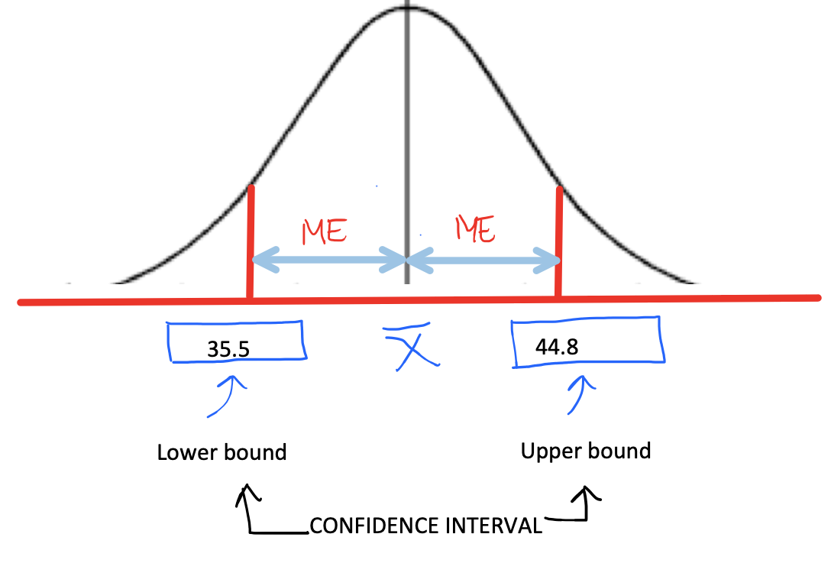

The **point estimate** is the value in the center of the CI. To find it, take the average of the lower and upper bounds.

The **margin of error (ME)** is the distance from the point estimate to either the upper or lower bound. For example, I can take the upper bound minus the point estimate to get the margin of error (ME) or I can take the point estimate minus the lower bound to get the ME. Alternatively, it is the difference between the upper and lower bounds divided by 2.

## Examples find the Point Estimate and ME given a CI

Example 1: We are 90% confident that the population mean age of patrons at a local restaurant is between 35.5 and 44.8 years old. Find the point estimate for the true mean age and the margin of error (ME). Round to two decimal places.

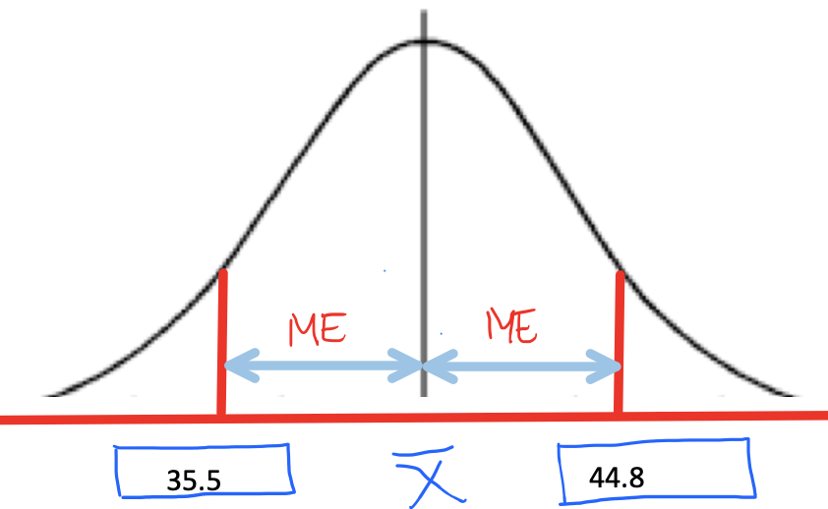**ANSWER:**

Find the center of the lower and upper bounds to get the point estimate: (35.5 + 44.8) / 2 = 40.15 years old.

Find the distance from the upper bound to the point estimate. This result is the margin of error (ME): 44.8 – 40.15 = 4.65 years.

Alternatively, you can find the margin of error by taking the (UB – LB)/2.

44.8 – 35.5 = 9.3 and divide this by 2.

9.3/2 = 4.65 years

Example 2: We are 95% confident that the true mean systolic blood pressure for US adults is between 126.7 and 127.9. Find the sample mean systolic blood pressure used to build the CI and the margin of error (ME).

**ANSWER:**

Find point estimate/sample mean: (126.7 + 127.9) / 2 = **127.3**

Find margin of error: 127.9 - 127.3 = **0.6**

# Understanding How a CI Changes

Let’s look again at the anatomy of the CI formula and discuss what happens if certain values were to be changed.

Consider the following example: Almost all employees working for financial companies in New York City receive large bonuses at the end of the year. A random sample of 65 employees working for financial companies in New York City selected showed that they received an average bonus of $55,000 last year with a standard deviation of $18,000. Construct a 95% confidence interval for the mean bonus that all employees working for financial companies in New York City received last year.

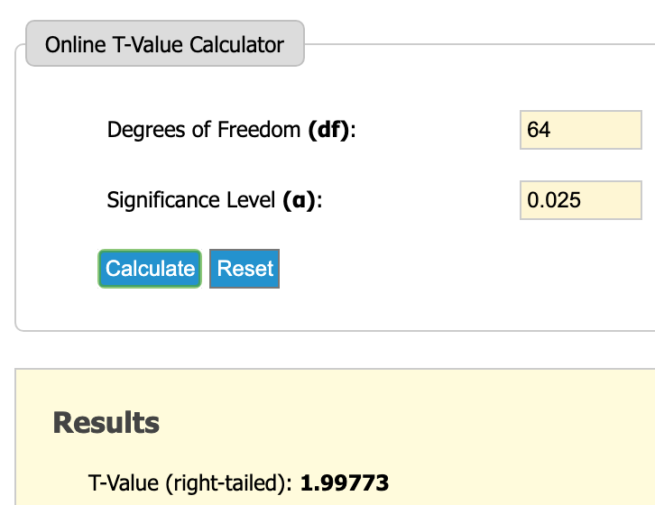

NOTE: t = 1.99773 is the t-value for df = 64 with 95% confidence (right tail area = .025) using a T-table or technology. You do not need to know how to find this value since it is done for you when building CI. If interested, use this [T-Table Calculator Website](https://goodcalculators.com/student-t-value-calculator/)

Let’s look at the values and where they go:

**QUESTIONS YOU NEED TO BE ABLE TO ANSWER:**

**What happens to the CI if we decrease the level of confidence to 90%?**

A 90% CI is a narrower interval compared to a 95% CI. The change in the formula would be as follows: The t-value associated with 90% confidence is smaller than for 95% confidence, which makes the calculation of the margin of error smaller which results in a narrower CI.

**What happens to the CI if we increase the level of confidence to 99%?**

A 99% CI is wider than a 95% CI. The change in the formula would be as follows: The t-value associated with 99% confidence is bigger than for 95% confidence, which makes the calculation of the margin of error bigger, which results in a wider CI.

**What happens if we increase the sample, but all other values remain the same?**

If n increases, then the overall calculation of the standard error would decrease. Notice that n is in the denominator of the standard error. As the denominator gets bigger, the overall value of SE gets smaller. If the standard error (SE) decreases, then the overall margin of error decreases which results in a narrower CI.

**What happens if the standard deviation of the sample increases, but all other values remain the same?**

If s increases, then the standard error (SE) also increases. If SE increases, then the ME increases and the interval is wider.

# Important Z-values Associated with Confidence Intervals

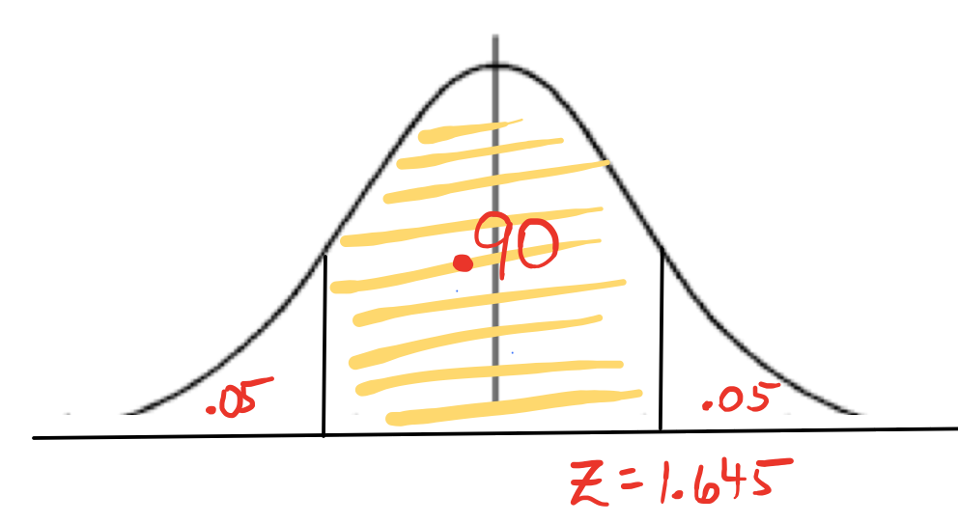Although we are working on the T-curve, there are situations where we may want to work with values from the Z-curve. Once such situation is when researchers have not yet conducted their research and want to calculate the minimum sample size needed to achieve their goals. This is called estimating a sample size needed and is covered in the next section. I am taking a quick aside to show you the three Z-values that we end up using often in statistics.

90% confidence leaves .05 in the right tail. The corresponding Z-value = 1.645.

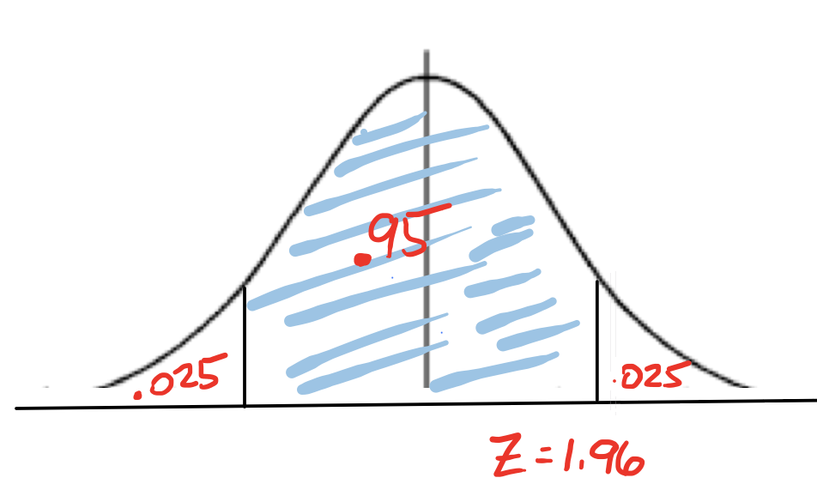

95% confidence leaves .025 in the right tail. The corresponding Z-value = 1.96.

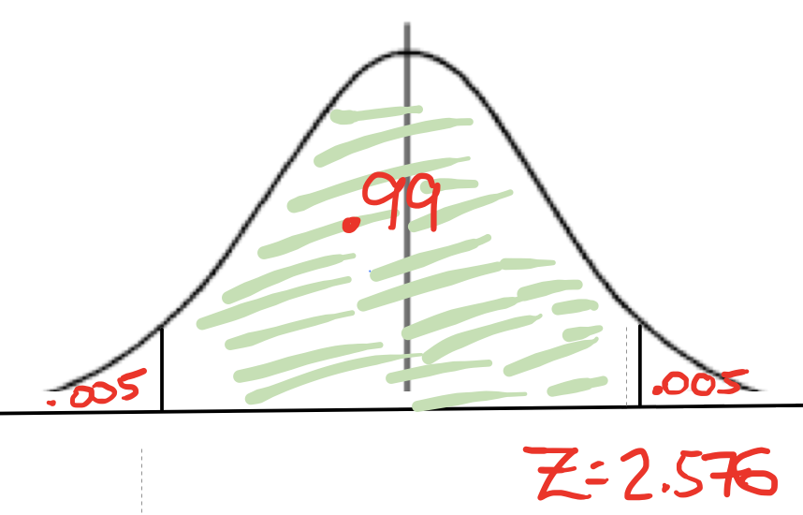99% confidence leaves .005 in the right tail. The corresponding Z-value = 2.576.

## Video Discussing Important Z-values in CI from Prof. Coffey

Here is a video discussing important Z-values: <https://youtu.be/DxrjZvp1GVE>

Here is the same video with interpreting: <https://youtu.be/zltL7kzFqiI>

# Estimating Sample Size with Numerical Data

In preparation for a research study, you may be interested in estimating the size of the sample that is needed so that you can achieve a certain margin of error at a certain level of confidence.

Solve for n using Algebra and replace t with z.

Round UP to the nearest integer

**What value do we use for 's'?**

If a prior study was already completed, it is reasonable to use the sample standard deviation (s) from the prior study. If a prior 's' value is not known, make an educated guess by taking range divided by 4 as the value for 's'.

**Why is there a Z value (and not t)?**

Notice that the tcrit was replaced with a zcrit. At this point, we do not know sample size (it is what we are trying to estimate!) so we are unable to use the t distribution since we do not have degrees of freedom (df). In its place, we will just estimate with zcrit.

Recall (from previous page): 90% CI zcrit = 1.645, 95% CI zcrit = 1.96, and 99% CI zcrit = 2.576

**Where do I get the margin of error (ME)?**

The margin of error (ME) will be given in the problem. It will be stated like "...estimate the mean cost ***within*** 5 dollars"---this means the ME = 5.

## Example Estimating Sample Size

You would like to estimate the mean systolic blood pressure of British adults with 95% confidence and a margin of error no larger than 2 mmHg. A previous study indicated a sample standard deviation of 10 mmHg. How many samples should you obtain?

**Answer: 97**

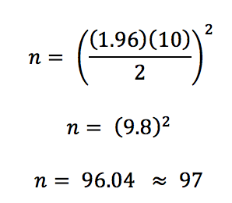

## Video Estimating the Sample Size Needed from Prof. Coffey

Here is a video estimating the sample size needed: <https://youtu.be/NeEph8GTCkA>

Here is the same video with interpreting: <https://youtu.be/Rl9yr8eM6hA>

# Additional Week Six Example

The following example asks many different questions related to confidence intervals and the topics covered this week.

The concentration of mercury in lake waters is important to monitor (too much mercury can cause serious health problems). A recent accident at a lakeside factory may have leaked mercury into the water. So, a team of environmentalists collected containers of water from randomly selected locations in the lake and measured the mercury concentration (mg/m3) in each. See the sample below. The data is in the 6_Week 6 STAT 145 Data.xlsx under the Sheet: **Mercury Level**.

|  |  |  |  |  |  |  |  |
| --- | --- | --- | --- | --- | --- | --- | --- |
| 1.60 | 1.45 | 1.77 | 1.52 | 1.61 | 1.43 | 1.25 | 1.98 |
| 0.98 | 1.20 | 1.79 | 0.85 | 1.34 | 2.11 | 1.07 |  |

1. Estimate the mean mercury level in the lake with 90% confidence.

StatHelper Output

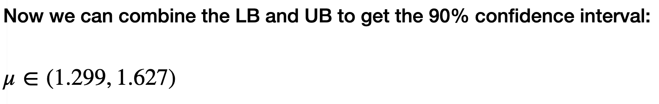

**Interpretation: We are 90% confident that the true mean mercury concentration in the lake is between 1.299 mg/m3 and 1.627 mg/m3.**

1. Check the assumptions for building a 90% CI.

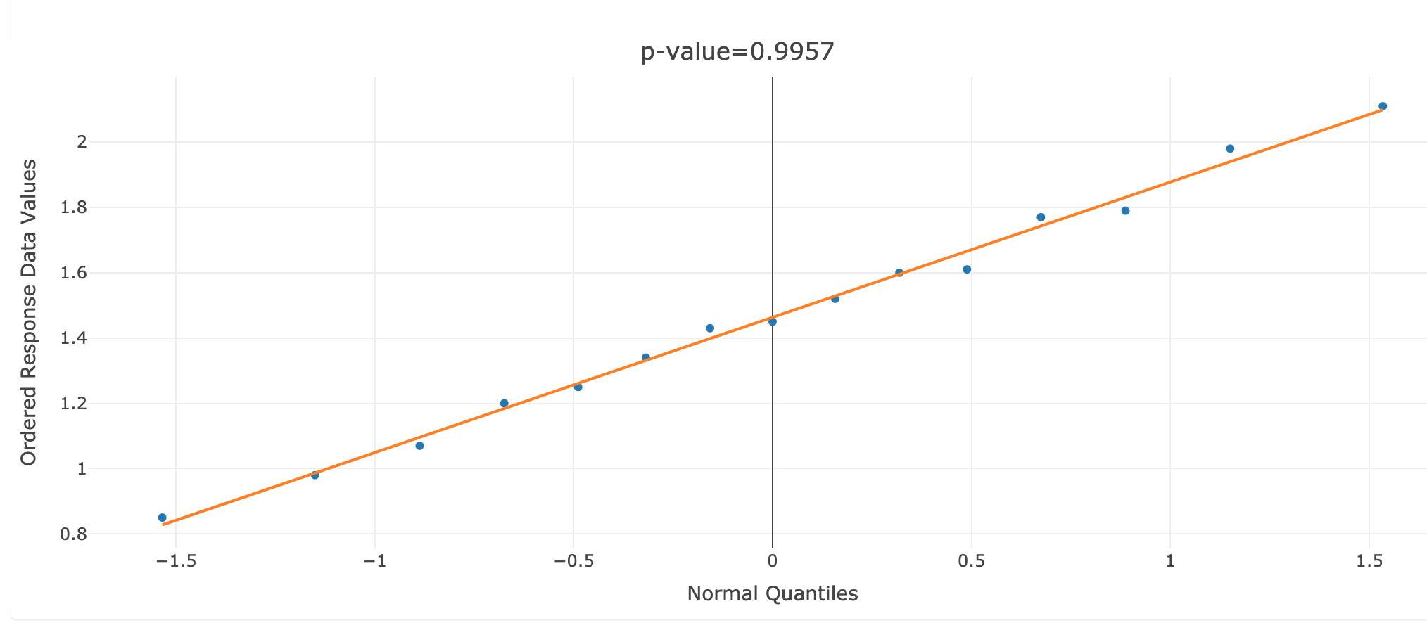

**Conclusion based on NPP: Since the P-value is > 0.05, we have met the normality assumption.**

1. Is a mercury concentration of 1.25 mg/m3 reasonable based on your CI? Explain your decision.

**ANSWER: No. Based on the 90% CI, 1.25 is not a reasonable mercury concentration since it is not in the bounds of the CI we built.**

1. Is a mercury concentration of 1.50 mg/m3 reasonable based on your CI? Explain your decision.

**ANSWER: Yes. Based on the 90% CI, 1.50 is a reasonable mercury concentration since it is in the bounds of the CI we built.**

1. Explain if you can be 90% confident that the mean mercury level in the lake is more than 1.25 mg/m3?

**ANSWER: Yes, we can be 90% confident that the mean mercury level in the lake is more than 1.25 since the entire CI is greater than 1.25.**

1. Explain if you can be 90% confident that the mean mercury level in the lake is less than 1.60 mg/m3?

**ANSWER: No, we cannot be 90% confident that the mean mercury level in the lake is less than 1.60 since the entire CI is not less than 1.60. Even though some of the CI is less than 1.60, it is possible that the true mean level is 1.61, 1.62, or as high as 1.627. Recall that any value in the CI is equally likely to be the true mean mercury level of the lake. In order to be 90% confident that the true mean level is less than 1.60, the entire CI would need to be less than 1.60.**

1. Using the CI results from part A. Calculate the margin of error?

**ANSWER: 1.627 – 1.299 = .328**

**Margin of Error ME = .328/2 = .164**

1. Your colleagues are planning a study in which they hope to estimate mercury concentrations within **.10 mg/m3**with **99%** confidence. What sample size should be obtained to achieve this?

**The previous data resulted in a sample standard deviation of .3611**

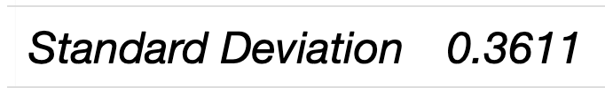

= 86.53

**ANSWER: A sample size of 87 samples should be obtained.**